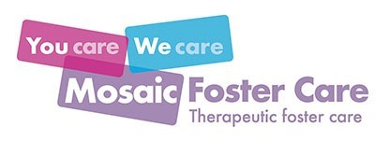

Statement of Purpose
Fostering Service - August 2021

Statement of Purpose
Fostering Service - August 2021
This Statement of Purpose was developed to meet the requirements from the following documents:
The Care Standards Act 2000
The Children Act 1989 and subsequent amendments
The Fostering Services Regulations England 2011 and subsequent amendments
The National Minimum Standards for Fostering Services.
Mosaic Foster Care is a Private Ltd Company (reg no 07133494) providing placements for children and young people up to age 21. Mosaic Foster Care Ltd is owned and operated by its sole Director.
Director – Andre Palmer MA, BA, DipSW
The agency was established in 2010 and merged with Kites Children’s Services Fostering in 2015, which was owned by the same Directors.
It is registered with Ofsted (Reg no. SC417598) and we are members of the Fostering Network, CoramBAAF, and the National Association of Fostering Providers.
This Statement of Purpose relates to:
Mosaic Foster Care Ltd Suite 2 Chalkwell Lawns 648-656 London Road Westcliff-on-Sea Essex SS0 9HR

Table of contents
Page 4 - What we do
Page 5 - Mission, Vision, Values
Page 6 & 7 – SMILE
Page 8 & 9 - 14 Reasons Why Mosaic Foster Care
Page 10 - Aims and Objectives
Page 11 - Our Business Structure
Page 12 - The Mosaic Team
Page 13 - Fostering Placement Services
Page 14 - Fostering Placement Types
Page 15 & 16 - Social Work Services
Page 17 - Mosaic Therapeutic Services
Page 18 - Recruitment & Assessment
Page 19 - Mosaic Foster Parents
Page 20 - Foster Parent Review
Page 21 - Training Foster Parents
Page 22 - Supporting Foster Parents
Page 23 - Mosaic Facts & Figures
Page 24 – Representation and Complaints Procedure
Page 25 - Mosaic Further Information

What we do
We are a fostering agency providing therapeutic placements for children who have experienced trauma and who have associated emotional, behavioural and attachment difficulties. For these children a permanent long-term placement coupled with therapeutic recovery is of paramount importance. All of the children who enter our specialist service receive individual assessment and therapeutic intervention by therapists who have expertise in working with traumatised children.
Our therapeutic approach is integrated into all aspects of our fostering service including recruitment, training, support and supervision for foster parents and staff.
We ensure that each child has the chance to tell their unique story so that their story can influence their time with us. It’s a small but vital part of work, that helps make the bigger picture.

Mission, Vision, Values

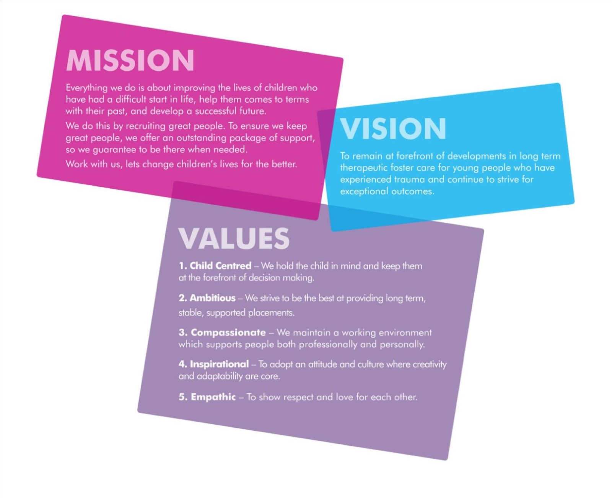

SMILE
SMILE is our integrated therapeutic approach which supports, and helps enable, our foster parents to deliver therapeutic parenting.
The term therapeutic, according to the Cambridge dictionary means, “causing someone to feel happier and more relaxed or to be healthier”. Many of our children have had a difficult start in life and therefore our aim is to make them happier, more relaxed and healthier and this will help them to develop their education, hobbies, interests and social and emotional skills.
Developed over the last 10 years we have formalised our approach into an easy to understand and memorable term - hence SMILE!
Safe.
For young people who have experienced Adverse Childhood Experiences the need to be safe, and in particular, feel safe, is very important. We have developed robust forums which are held at least every three months, to ensure that our team, working with other professionals such as teachers and health workers, are prioritising and proactively ensuring that our children feel and are safe. There are many ways in which we ensure that the safety of our foster parents, children and staff is at the centre of our work.
Multi-Skilled Team.
‘It takes a village to raise a child’, is certainly true in many societies. For Mosaic Foster Care this realisation has meant the development of many different types of team member, with different skills and qualifications, working together to help support our children and foster parents. We have social workers, child support workers and therapists from a range of disciplines, all working effectively together with professionals from health and education. Having these different disciplines offers different perspectives and helps support our foster parents to deliver therapeutic parenting and avoid compassion fatigue.
Intentional.
Developing a connection with a child is fundamental to facilitating change. We were early adopters of the Secure Base Model, which is based on attachment theory. We also use elements of Dan Hughes’ PACE model (Playful, Acceptance, Curiosity and Empathy) as a further way for our foster parents to connect with children. Once truly connected, our foster parents can then utilise intentional parenting strategies, designed and informed by our social workers and therapists. Intentional parenting focuses on carefully crafted plans which make it easier to respond to the child and not react to behaviours.
Regular consultation with our therapists and social workers will also ensure that our foster parents are connected to their own experiences which ensures our foster parents own well-being is nurtured.
Long term.
Our agency focuses only on long term therapeutic placements. The reason for this is that we know that children who have had Adverse Childhood Experiences need a secure base placement over time to recover from their experiences. Trauma affects the way a child’s brain develops, but we know that with the right care, the brain can recover and rebuild connections that were not made in earlier childhood. This requires skilled intervention by specialists not usually available to foster parents.
Environment.
Trauma, and particularly trauma which occurs within relationships, is characterised by unpredictability and a lack of control. Children who have experienced Adverse Childhood Experiences often operate from a fear-based world view and therefore find it difficult to trust any caregiver. High structure through consistent boundaries, held in place by nurturing yet firm parents, is something the child can depend on. Over time, the child experiences this structure as dependable and predictable; the opposite of their previous experiences.
High structure can seem quite cold and clinical which is why the careful balance of high structure AND high nurture is so important. Often children’s experience, which is imprinted on their brain and view of the world, is that they are not lovable or liked. So often, lots of nurture is at odds with the child’s experience and they can seemingly push away. However, over time and with the right balance, the child’s experience of high nurture does begin to change their perception.
No foster parent is perfect but with the support of your social worker and therapist we find that our foster parents get the balance just right!

14 Reasons why you should foster with us
- Owner founded and operated by an experienced social worker – Having someone who has worked in social care for over twenty years means they really understand the work you do.
- Joined up therapy – Understanding the impact of hurt on a child’s inner world is vital to their recovery – which is why we employ therapists who can work 1:1 with children and foster parents.
- Supervising Social Workers – With protected caseloads (no more than 10 foster parents) our staff are always there when it matters.
- Weekly reflective groups – All our staff and foster parents participate in regular reflective groups. Our foster parents meet every week via video call with our therapeutic lead to take time to reflect.
- Robust out of hours service – We know that fostering is a 24/7 role – that’s why we have developed a system of staff support to ensure we can be there when you need us most. With staff that can actually visit you at any time of the day or night, if needed, you know that real support is only a call away.
- SMILE therapeutic model – A straightforward way of understanding the role of therapeutic parenting and therapeutic work with our children and young people, implemented through training, reflective groups and an annual conference.
- Support workers – Unusually for most fostering providers we employ support workers who are properly supported by the agency, employed with both practice and therapeutic supervision to ensure that their work is properly allocated, monitored, reviewed and therapeutically informed.
- Dedicated ‘support’ foster parents - Every full-time foster parent is allocated two ‘support’ foster parents. This ensures that children experience consistent relationship-based care, whilst giving you a well-earned paid break, for up to 3 weeks per year.
- Local quarterly support groups – We know being a foster parent can be isolating, which is why our foster parents really enjoy meeting with like-minded people.
- Robust referral, matching and placement process. All placements are planned without exception – our matching has been described as meticulous by Ofsted (2019).
- Mosaic children and youth clubs hosted by support workers who run weekly clubs focusing on arts and crafts or walk and talk – providing a fun time for our children.
- Safeguarding case reviews – We want our children to be safe and feel safe and ensure their needs are being met – that’s why we meet as a team (including the foster parents) at least every 3 months for each child.
- Only the right foster parents – We are very selective in our assessment and approval processes. None of our foster parents have children under the age of 12 living at home. This enhances their ability to focus on the placed child and reduces potential conflicts within the home.
- ‘Paperless’ data records - All of our foster parents are allocated iPads and direct access to their files and their child’s files through their own Mosaic email address.

Aims & objectives
To provide therapeutic placements for children who have experienced trauma through abuse and/or neglect, and who have associated emotional, behavioural and attachment difficulties.
To ensure that all our children are provided with a permanent long-term stable placement coupled with therapeutic recovery.
Ensure that all children who enter our specialist service receive individual assessment and intervention by therapists who have expertise in working with children who have experienced trauma.
Ensure our therapeutic work is undertaken in a collaborative way, ensuring that the child’s story helps influence the wider systemic context.
To comply with and exceed, regulatory and best practice frameworks in all aspects of our functioning as an agency.
To recognise the impact of adverse childhood experiences and promote recovery through therapeutic support and intervention.
To work in partnership with other stakeholders whilst maintaining focus on the needs of the children we care for.
A firm commitment to the training and development of our foster parents, and our people, to ensure they have the knowledge and skills to deliver excellence.
To provide first class out of hours support through the provision of a multi-tier support system comprising of on call director, manager, social worker, support worker and support foster parent.
To recruit foster parents from diverse backgrounds and skill base so that we can find the right placement for children and young people.

Our business structure
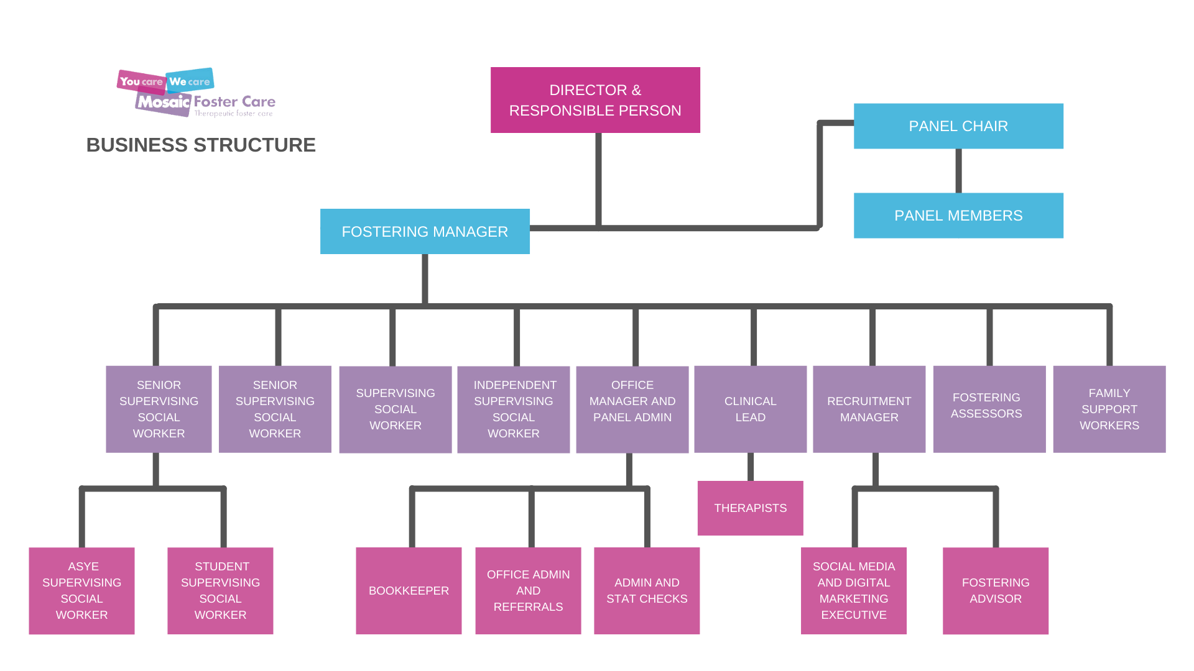

The Mosaic team
All managers are professionally qualified in line with the requirements of regulations and National Minimum Standards. The director holds a range of social work and degree qualifications and previous social care employment suitable to their level of managerial responsibility.
All social workers and their managers are professionally qualified and registered individually with Social Work England. Many have post qualifying specialist awards and experience related to working with children and young people in foster care.
Our therapists hold appropriate qualifications, experience and membership of a training body that includes registration with a nationally recognised organisation. Our therapists have access to external clinical supervision as well as organisational line management.
A number of people work for our organisation on an independent, self-employed basis across a variety of roles. All self-employed workers are required to provide verification of any formal qualifications in relation to the work undertaken. All staff regardless of their employment status are subject to a rigorous recruitment process to ensure that the welfare of children and young people is safeguarded. All those commissioned on a self-employed basis hold the appropriate professional indemnity and public liability insurance that is checked and verified.
As of August 2021, Mosaic Foster Care had the following staff:
- 1 Director
- 1 Registered Fostering Manager
- 1 Office Manager
- 1 Recruitment Manager
- 4 Supervising Social Workers
- 2 Therapists
- 1 Fostering Advisor
- 1 Administrator
- 6 Support Workers
- 1 Bookkeeper
- 1 Social Work Student
- 1 Marketing Officer

Fostering placement services
All our fostering placements are subject to a thorough matching process, which carefully assesses the likelihood of a match between the skills, experiences, and aptitudes of our foster parents with the needs of the child.
All of our placements are made in accordance with the Fostering Services Regulations. All our foster parents are approved and have a signed foster parent agreement that is regularly reviewed.
We have contractual arrangements with a number of consortia and Local Authorities across London and the South East of England.
Placement plans are prepared for each placement between commissioners, foster parents, and the agency to ensure that all essential information is gathered and there is clarity of delegation for the foster parents for each child placed.
All our placements are planned and therefore a great deal of preplacement planning is undertaken including introductory visits, file reading when possible and discussions with previous foster parents/schools.
We ensure the ethnic, cultural, and linguistic needs of children are attended to and consideration is given to their gender and sexuality when making placement decisions.
We ensure that our foster parents’ homes comply with health and safety requirements. Safeguarding children in our placements is of paramount importance. To this end a safer care plan specific to the child in place is agreed and we have robust procedures to review and monitor the welfare and safeguarding of children in our care.
Fostering placement types
Therapeutic Placements for Children and Young People with complex needs.
Typically, this group will have experienced multiple traumas resulting in emotional and behavioural difficulties. They will often have experienced multiple placement breakdowns or be at risk of developing them.
These placements require multiple support services to support them and includes but is not limited to:
- Individual assessment and therapy for the child
- Therapeutic group reflection sessions for the foster parents
- Therapeutic individual supervision for foster parents
- Multidisciplinary safeguarding reviews
- Therapeutic reflection sessions for social work and support staff
- Direct work by therapists and support staff informed by the child’s assessment of need
- Close liaison with schools, colleges, and virtual school staff through safeguarding and education meetings
- Regular health checks and medical reviews with local health providers and where required, specialist health consultants

Social work services
Our social workers are trained to ensure that the children and young people’s welfare is paramount. They work in partnership with the foster parents to ensure that the children and young people’s needs are met and that they are provided with a safe, nurturing placement where they are able to meet their potential and achieve therapeutic recovery.
The Secure Base Model is drawn from attachment theory, and adapted to include an additional element, that of family membership, for children who are separated from their birth families. The model proposes five dimensions of caregiving, each of which is associated with a corresponding developmental benefit for the child. The dimensions overlap and combine with each other to create a secure base for the child, as represented below.

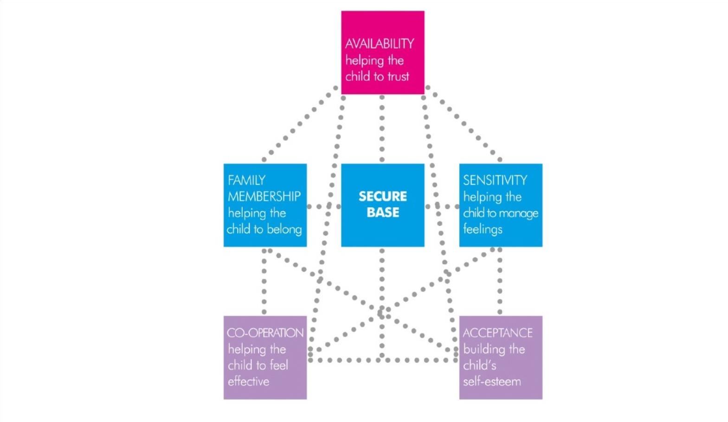
The Secure Base Model:
The Secure Base Model provides a framework which can be of help when assessing the capacities of caregivers (birth parents, residential workers, foster parents, and adopters) to provide a secure base for children in their care.
The supervising social worker will visit the foster parents regularly to undertake supervision. These times are an opportunity to discuss the day-to-day care needs of the children and young people and how the foster parents are working to meet those needs and progress the placement care plan.
Foster parents’ training needs will be assessed and discussed through supervision meetings and for those foster parents the supervising social worker will undertake an unannounced visit annually.
Mosaic Foster Care also carries out annual health and safety inspections of each fostering household to ensure a high standard of accommodation. The supervising social worker will attend all meetings and reviews with the foster parent, prepare reports for annual reviews and keep a thorough and accurate record of all fostering activity.
Our social workers act us a hub for all information about the foster child’s placement ensuring that communication is effective between all parts of the system that serve the child and placement.
Mosaic therapeutic services
Assessment Based Treatment
Assessment
All therapeutic interventions are led by comprehensive assessment undertaken by suitably qualified and experienced therapists, which begins soon after the placement commences. We always work directly with the child, as well as ensuring all information from multiple sources is synthesised into our assessment formulation. Utilising an assessment-based Treatment model leads to the development of an integrated plan of prioritised interventions ensuring that children’s need for therapeutic recovery are carefully planned through a structured assessment model. This will often involve individual therapeutic interventions with the children. As we only use our own people, there is no waiting list and due to the diverse group of therapists we use we are usually able to ensure appropriate gender and skills are provided to the child.
Intervention
Following assessment, a range of treatment pathways are available to address the particular needs of the child. Typically, the children referred to Mosaic have experienced multiple traumas though a range of abusive experiences including sexual, physical, emotional and neglect. Our approach couples secure base foster care with therapeutic interventions through a whole system approach. This approach avoids the ‘splits’ that can often occur in therapeutic work ensuring that the foster placement is as much the agent of change as the individual therapeutic relationship.
In addition to any therapeutic work undertaken with children, our therapists and practitioners work directly with foster parents the primary agents of change for the child. This ensures that each child receives the therapeutic parenting they require in a safe and nurturing family environment.

Recruitment & Assessment
We follow a clear procedure for recruiting our foster parents and our recruitment process is often much quicker than the 8 months from application to approval required by legalisation.
Marketing
We have our own dedicated recruitment team comprising of our recruitment manager, fostering advisors and marketing officer. Our recruitment team organise all marketing activity and are involved in various direct marketing activities in the communities we serve. They also coordinate all activity from initial enquiry, home visits, application through to our Skills to Foster preparation training.
Home visits
A fostering advisor undertakes initial home visits to gather information from potential applicants and provide an insight into the work undertaken by Mosaic Foster Care. The recruitment manager makes an assessment of the information which is gathered and for those people who are successful at this stage can then formally apply to be assessed.
Preparation training
We hold regular preparation courses for those who have applied to foster with us and are currently in assessment. These courses are also open to any of their adult family members who may be involved in supporting them in the fostering task.
Assessment
Potential foster parents who choose to apply complete an application form giving detailed information about themselves and their family and consent to enquiries to ascertain their suitability to foster.
Applicants are required to have medical examinations completed by their GP to ensure that there are no underlying issues that may affect their ability to foster. Reports are made available to our agency medical advisor for his/her comments.
Applicants are asked to identify at least three personal referees who will provide written references and be interviewed as part of the assessment process. References from external agencies and personal references, which are provided in confidence, cannot be accessed without the consent of both the subject and relevant referees. Additionally, safeguarding references are undertaken in respect of prior employment involving children or vulnerable adults.

Mosaic foster parents
A qualified social worker will carry out an assessment (Stage 2), which requires full participation by the applicants. She/he will visit them virtually by video and at their home, generally for a combined 6-8 sessions, to collect information about all members of the household and the applicants’ experience and skills in relation to fostering. This forms the basis of an assessment report.
During the assessment process, applicants are asked to compile a portfolio of written material giving examples of relevant experience, skills, and competence.
Applicants are expected to attend the Panel meeting with their assessor.
Our fostering manager has an overview of the pre-panel process to ensure regulatory compliance and quality control of the assessment.
The Panel makes recommendations about the suitability of applicants to be approved as foster parents with Mosaic Foster Care. It is the role of the Agency Decision Maker to make the final decision.
The company director of the fostering agency is designated as Agency Decision Maker for new approvals. The Agency Decision Maker reads and considers all the assessment information and the Panel recommendation and then makes the decision to approve applicants or not, taking into account the Hoffsetter guidelines.
Applicants are informed verbally (within 2 days) and in writing (within 5 working days) about the decision. All information obtained about prospective foster parents is held on secure electronic database files and all relevant sections are available to view upon making a subject access request and receipt of third-party consents.
Foster parent review
Each fostering household will have a review annually, unless there are significant changes to their circumstances in which case, we will conduct a review at that time.
These circumstances may include –
After the final strategy meeting of an s.47 investigation involving a foster parent(s)
Where allegations have been made regarding a foster parent(s) childcare practice and no s.47 investigation is pursued.
Where there has been a breakdown in the approved foster parents’ relationship resulting in one foster parent moving out of the household. In this instance both foster parents will be subject to review except where one/or both foster parents has given notice of an intention to resign.
Where there have been significant changes to the foster parents’ lifestyle.
Where there has been the death of a foster parent.
Where a foster parent has been diagnosed with a serious illness.
When a foster parent has stopped or started living with a partner.
Where a foster parent is not working in partnership with the agency including a lack of willingness to attend training.
The annual household review will address the foster parents’ training and development needs for the next year and suggest, if required, alterations to their approval status. The CoramBAAF competencies to foster are considered when forming an opinion of the overall success and progress of foster parents for the preceding year. Reports will be requested from the Local Authorities social worker, school, supervising social worker, foster parent, the child/ young person in placement, the birth family (if appropriate) and any other interested party.
Foster parents will be invited and encouraged to attend all Panel reviews.

Training foster parents
We are committed to ensure that all our foster parents receive high quality and relevant training to ensure they are able to meet the needs and safeguard the children and young people in their care. All our foster parents are required to complete a minimum amount of training or learning on relevant subjects as agreed by their supervising social worker and included in their Professional Development Plan, including but not limited to:
- Post-approval induction
- Training, Support, and Development Standards workbook
- Child protection and safeguarding courses
- Managing difficult behaviour/de-escalation
- Equality and diversity
- Paediatric first aid
- GDPR and data protection
- Health and safety
- Health and nutrition
- Food safety and hygiene
- Therapeutic parenting (through to independence)
- Understanding trauma, attachment, and resilience

Supporting foster parents
All our foster parents complete our Skills to Foster preparation training as part of their preparation to foster. Following approval all foster parents receive a comprehensive package of support and development opportunities including:
An agency induction programme delivered by the Registered Manager and a supervising social worker.
An IT induction programme delivered by their allocated supervising social worker.
A Referrals workshop to help them prepare for child placement considerations developed by our social work team in collaboration with some of our most experienced foster parents.
Assistance with completing foster parents training, support, and development standards within the first 12 months of approval. Regular supervisory home visits by their fostering social worker. Low caseload of supervisory social workers to foster parents meaning support is available when needed.
Regular therapeutic reflection sessions from their allocated therapist who also works directly with the child in placement. Attendance at safeguarding reviews which includes all professionals working with the child’s placement and chaired by one of our dedicated safeguarding officers.
A multi-tier on-call system comprising of a manager, social worker, support staff, and support foster parents who can respond by working directly with the child during out of hours or in exceptional circumstances provide emergency supportive foster care (with consent from placing authority).
Use of Mosaic Foster Care IT infrastructure to ensure compliance under the Data Protection Act (includes iPad, Mosaic email address, secure login to database).
Regular consultation between the agency and foster parents on important matters which effect foster parents, for example agreements, interventions, impact of Covid, etc.
A generous reward element to ensure we recruit foster parents who can dedicate the time required to care for the child placed. Regular events which bring together foster parents and children for social events such as our regular holiday activities, children and youth clubs, and annual events and trips.

Mosaic facts & figures
Foster Parents
As of August 2021, we have 34 fostering households of whom 6 are approved as dedicated support only carers. We currently have 25 children in placement utilising 23 of our fostering households. Our current vacancy rate of 18% (5 vacancies) means that we can offer choice to our local authority partners and is in line with most independent fostering agency vacancy rates and lower than the national average of 37% as of 31 March 2019 (Ofsted).
Children
We currently have 25 children in placement, all of which are placed in our core therapeutic service.
- 16 have been placed for 12 months or more.
- All children are placed on a long-term basis.
- 2 children are black or minority origin.
- 8 are female and 17 are male.
- The children’s ages range from 6 to 17 years.
- All children are on Care Orders (s31 CA 1989).

Representation and complaints procedure
All children/young people placed with our foster parents are informed of the Representation and Complaints Procedure on commencement of placement by their supervising social worker. They are provided with a children’s guide, so they are able to contact the Director and Fostering Manager directly if they wish. All foster parents, staff, and placing local authorities/health and social care trusts are provided with information about our Representation and Complaints Procedure. Information on complaints and advocacy for children is provided in every monthly newsletter. There is also a “Contact Us” page on our website where we can be reached by phone, text, email, post, or by visiting our main office.
Complaints and compliments
A summary of complaint outcomes and their impact upon service design and delivery are collated and are fed into our 90 Day developmental meetings when required. Mosaic Foster Care has a comprehensive Complaint Procedure which is available by emailing, calling, or writing to us.
External inspection
As a registered care service, we are subject to regular auditing, and we are proud of the outcomes. These are publicly available via the Ofsted or Mosaic websites.
Service improvement
We promote a culture of continuous improvement, giving careful attention to feedback about its services offered by any individuals or organisations with whom we come into contact. Operational staff are supported by managers (and other specialists) who focus on quality assurance throughout the company. Quarterly development meetings are held to ensure our strategic plans are implemented and reviewed.

Mosaic further information
Further information regarding policies, practice and procedures can be found in the following handbooks. These are reviewed and updated each April.
Employee Manual – outlines our employment practices.
Mosaic Fostering Policy – policies and procedures for foster parents and staff.
Mosaic Therapy Policy – outlines our assessment methodology and
therapeutic interventions.
Mosaic Safeguarding Policy – provides advice and guidance on
safeguarding and child protection incidents along with comprehensive safeguarding policies.
Mosaic Panel Policy – provides information on the work of the fostering panel including membership and procedures.

Mosaic Foster Care
Suite 2, Chalkwell Lawns, 648-656 London Road,
Westcliff-on-Sea, Essex, SS0 9HR
T. 01702 344088
F. 01702 344064
Em. info@mosaicfostercare.com
www.mosaicfostercare.com
092020011

